**Project Task 4:**

Objective:

Use Cisco packet tracer and implement Static Routing and OSPF routing using 3 routers.

1. **Static routing using 3 routers**
   1. 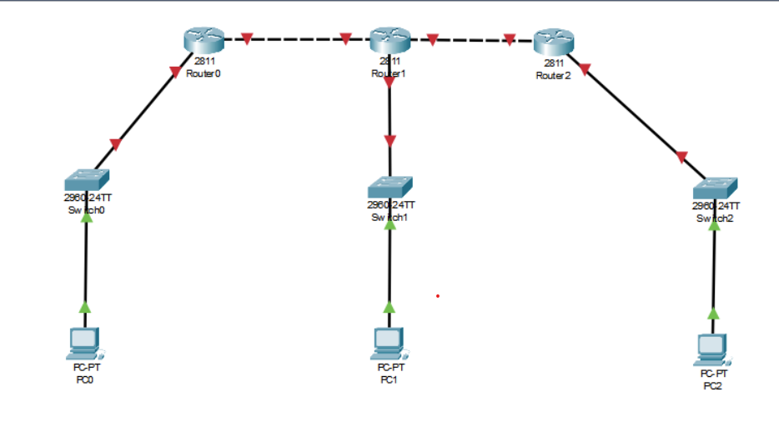Add the devices & connect them with appropriate wires.

**NOTE**: As the used **Router 2811** contains only 2 fast ethernet port we have to add another ethernet port to the router1 then only it will able to make 3 connections.

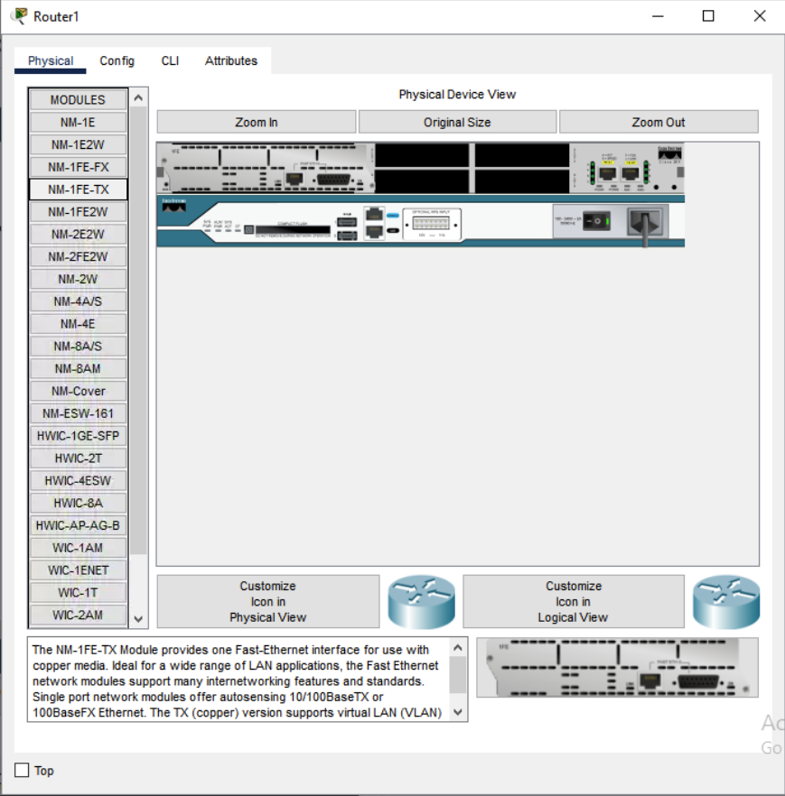

* 1. Configure IP address of each device
     1. 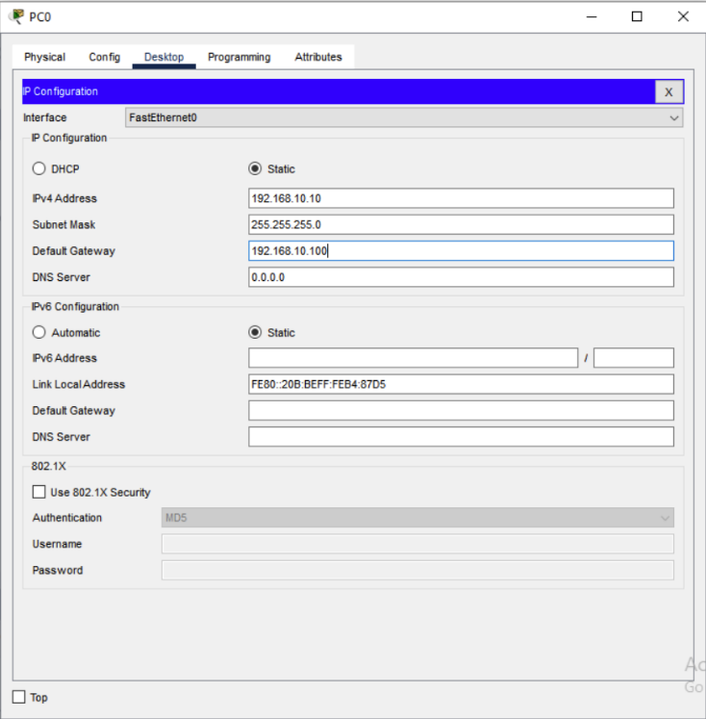PC0
     2. 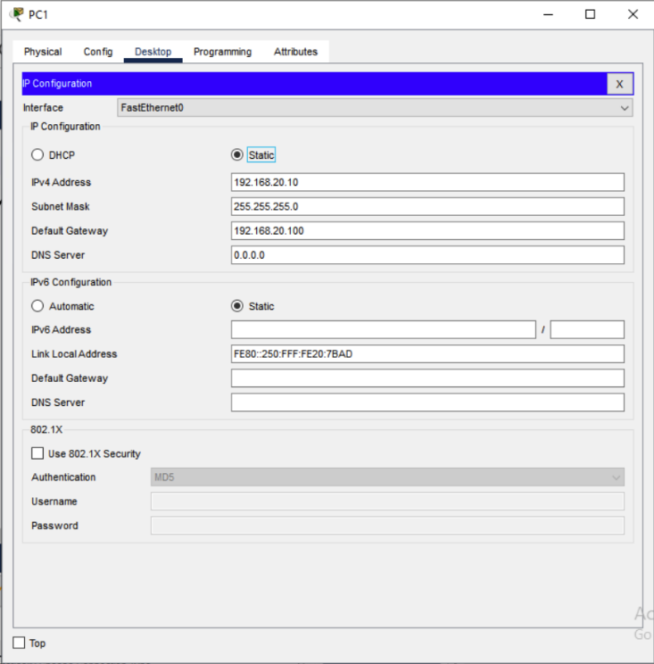PC1
     3. 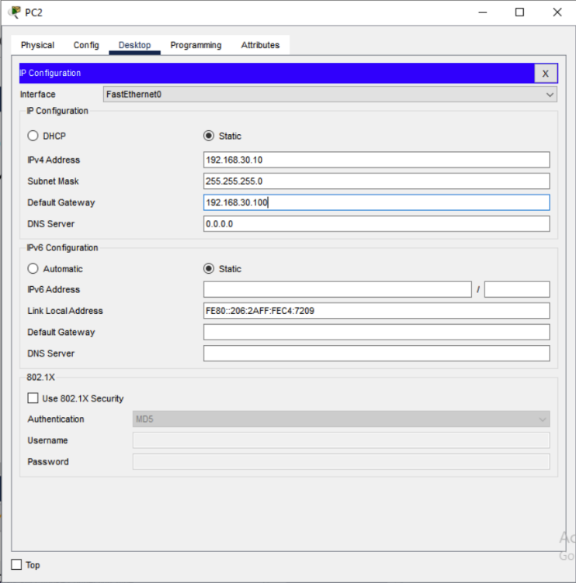PC2

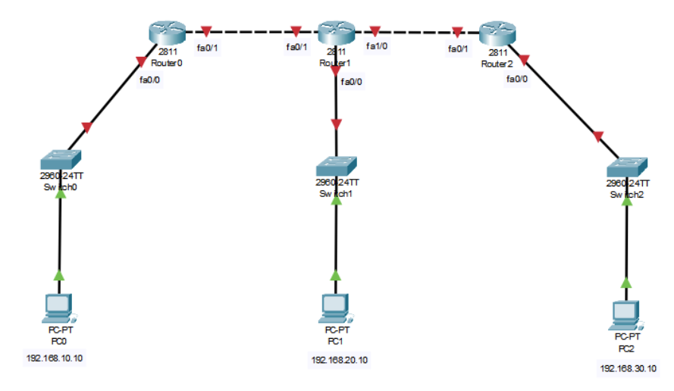

* 1. Configure all routers
     1. 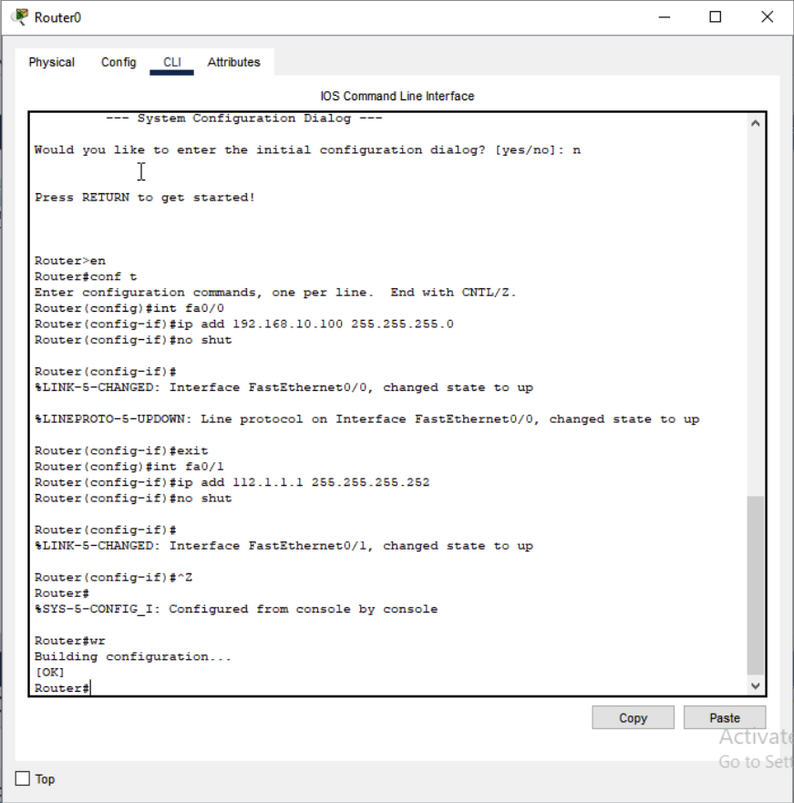Router0
     2. 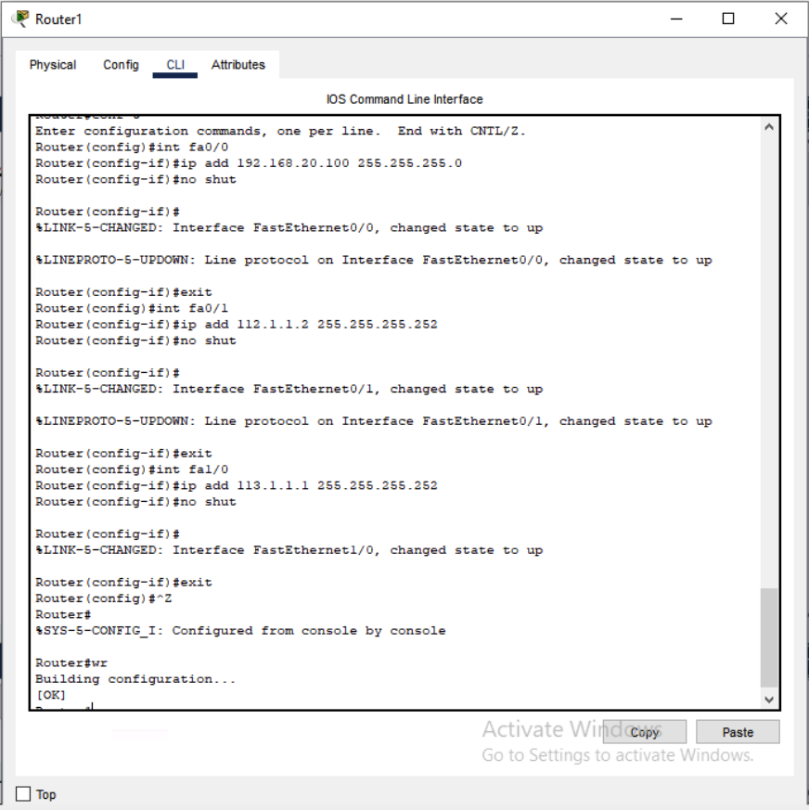Router1
     3. 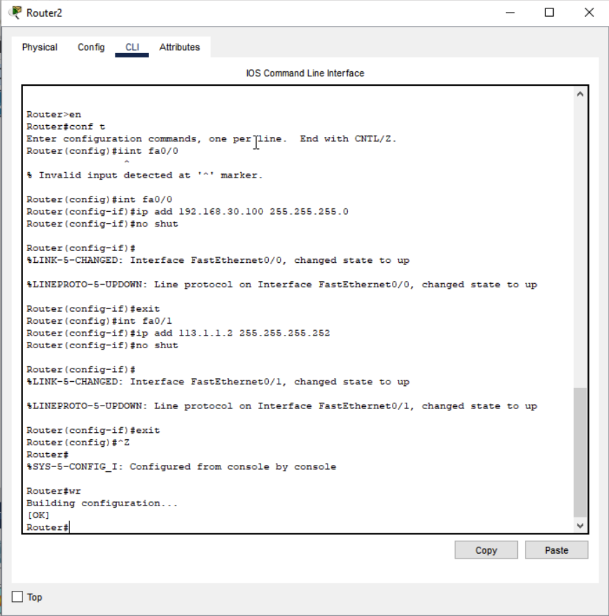Router2

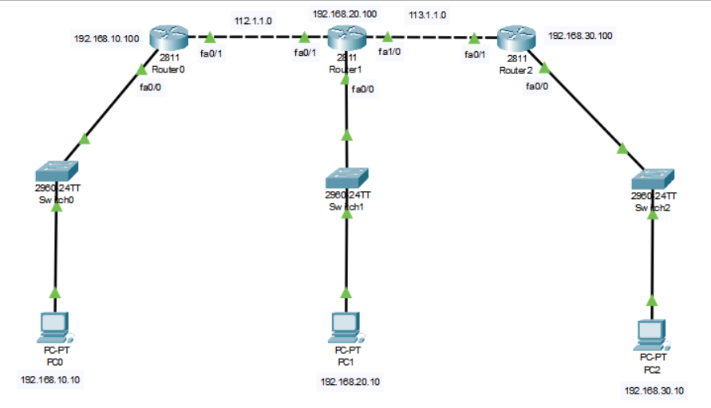**NOTE**: After Router Configuration

* 1. Static routing Configuration in routers
     1. 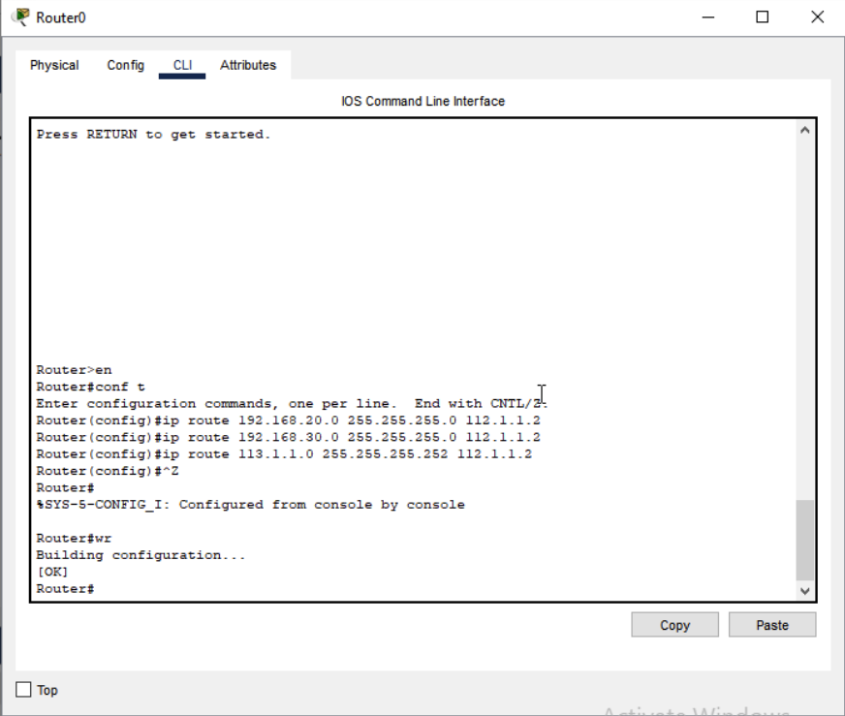Router0
     2. 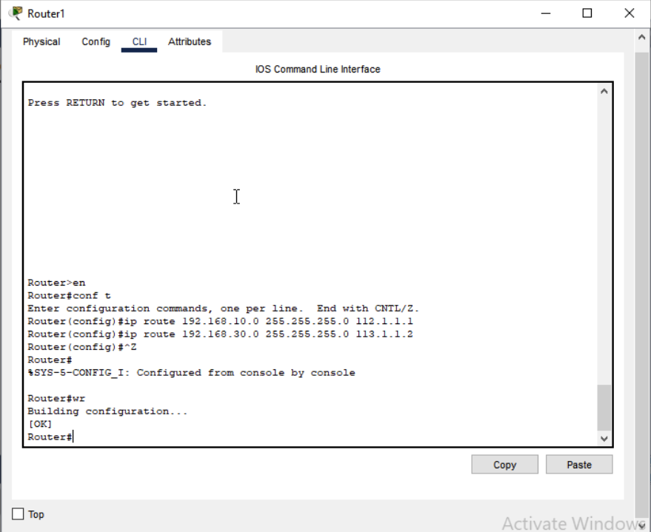Router1
     3. 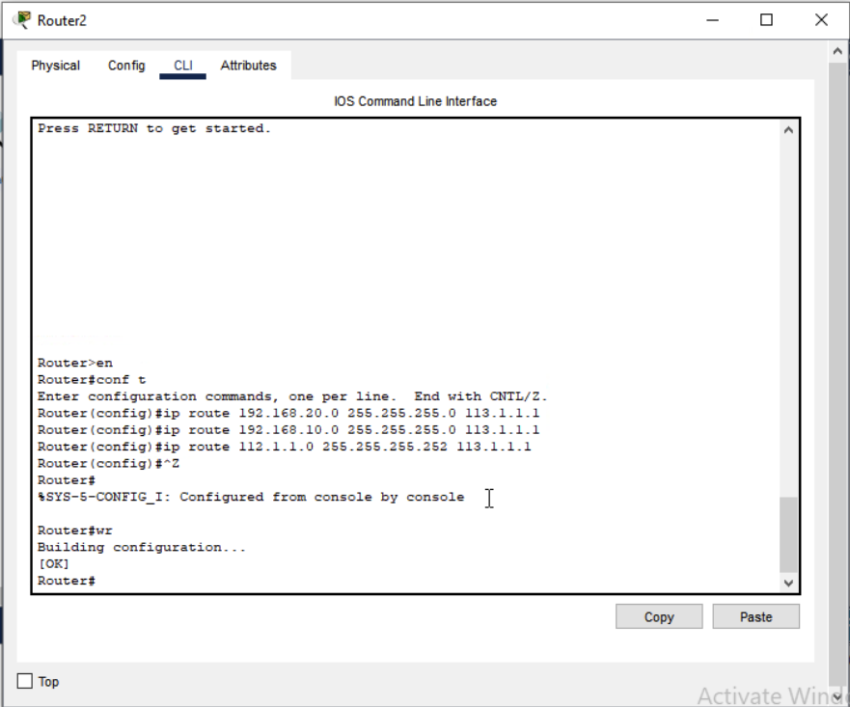Router2
  2. 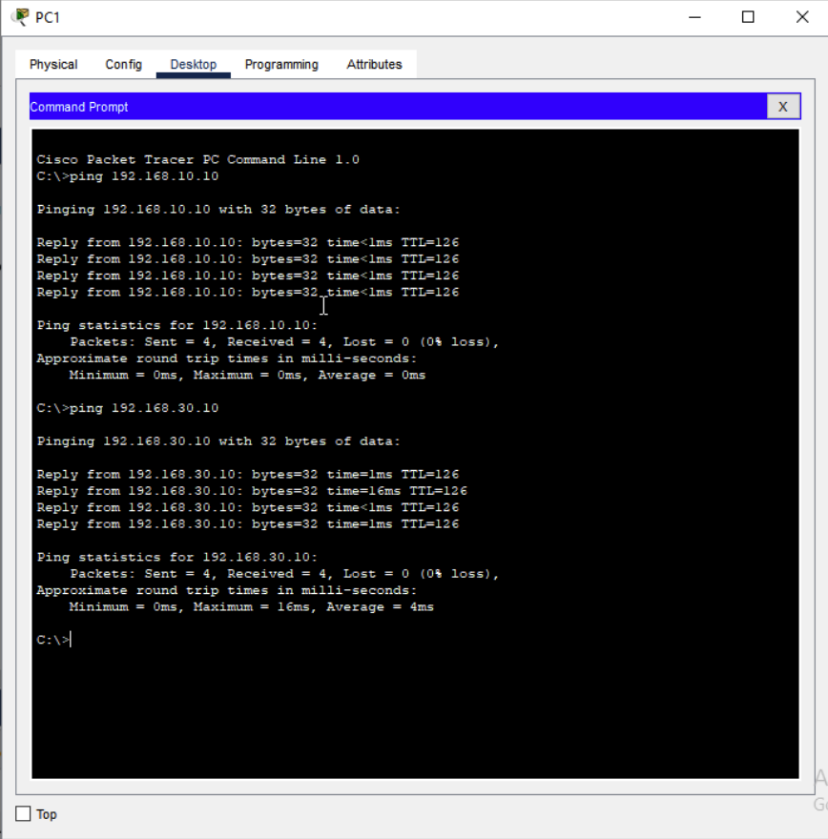Ping from PC1 to PC0 (IP:192.168.10.10) & PC2 (IP: 192.168.30.10) to verify the connection

1. **OSPF using 3 Router**
   1. 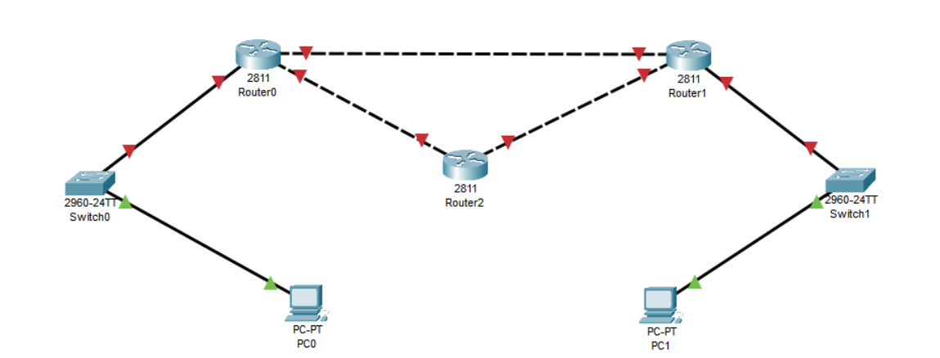Add the devices & connect them with appropriate wires

**NOTE**: As the used **Router 2811** contains only 2 fast ethernet port we have to add another ethernet port to both router0 & router2 then only will able to make 3 connections.

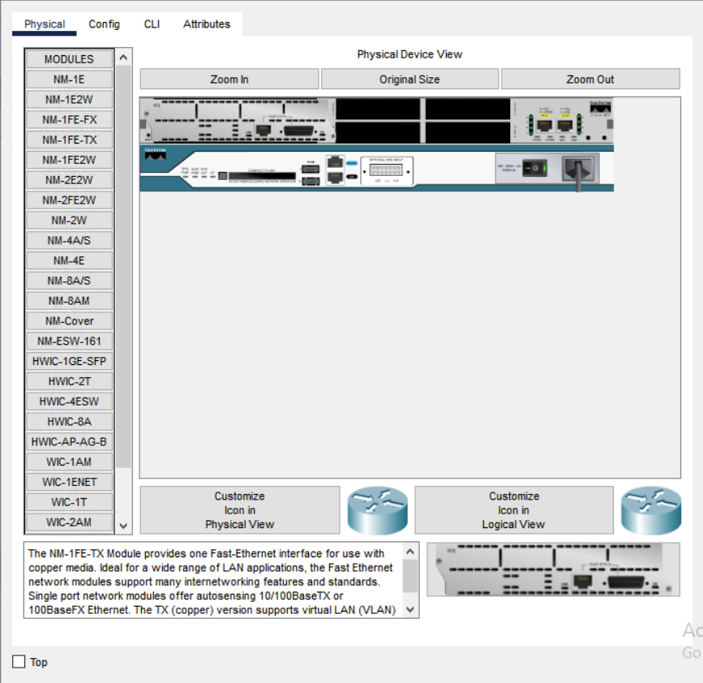

* 1. Configure IP address of all devices
     1. 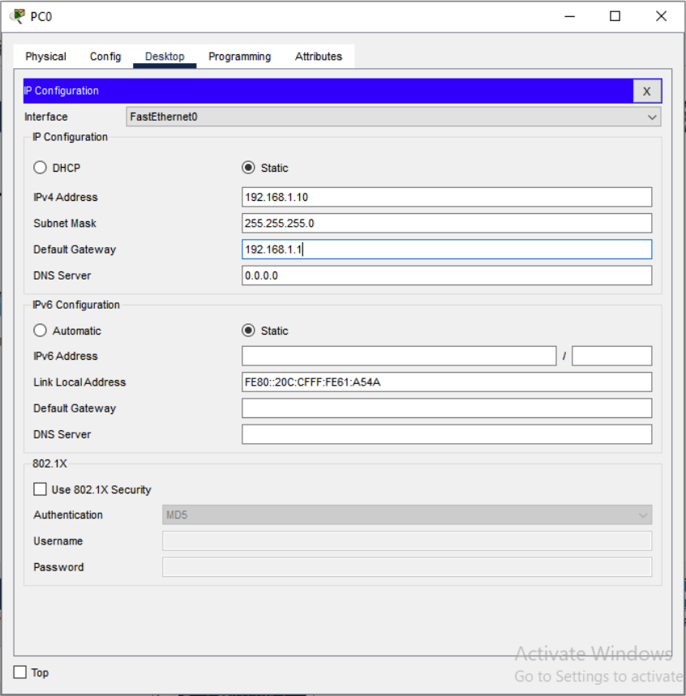PC0
     2. 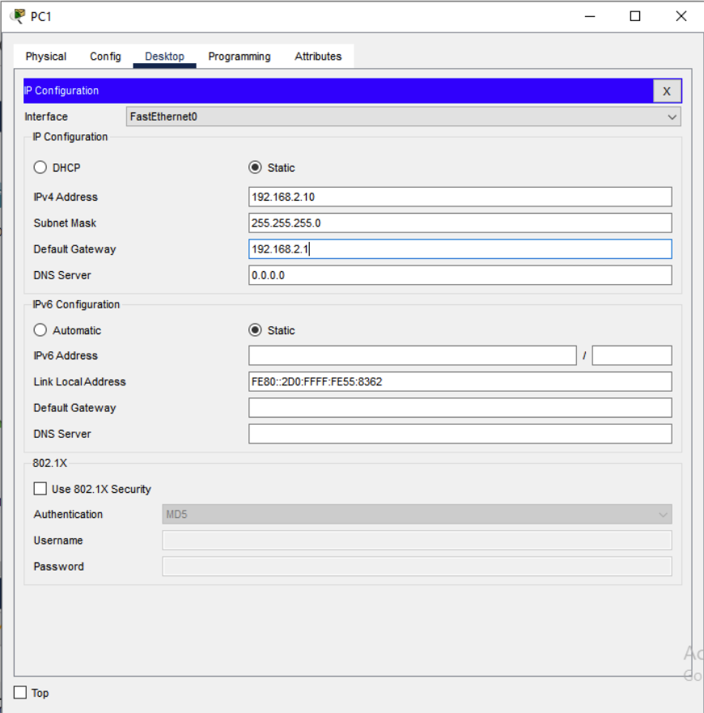PC1
  2. Router Configuration
     1. 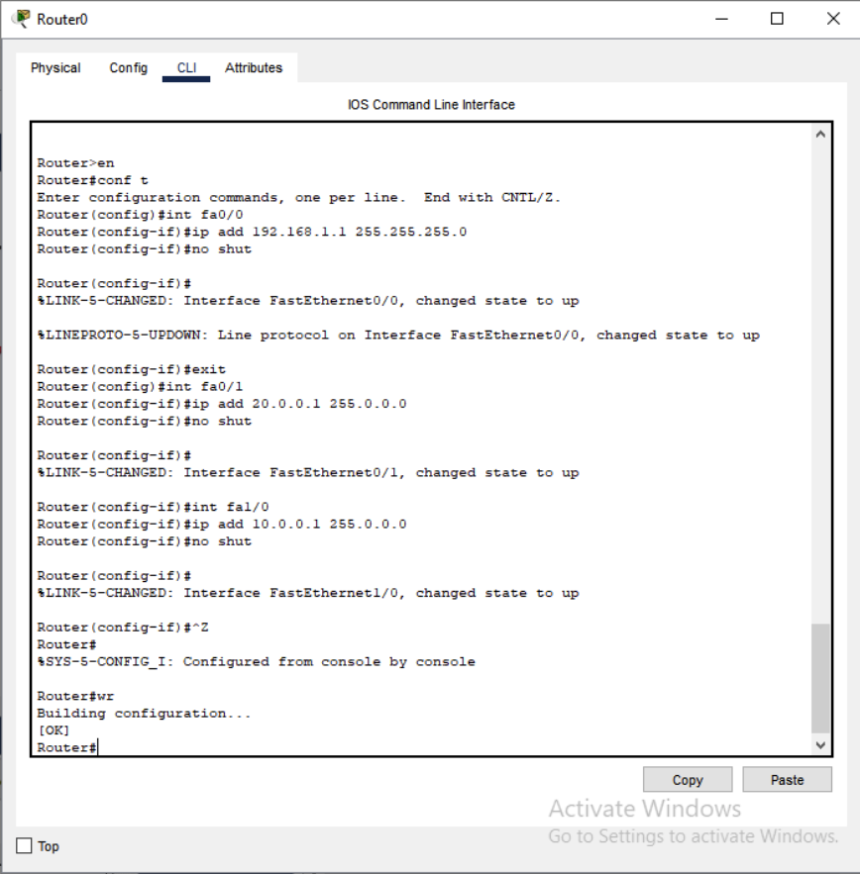Router0
     2. 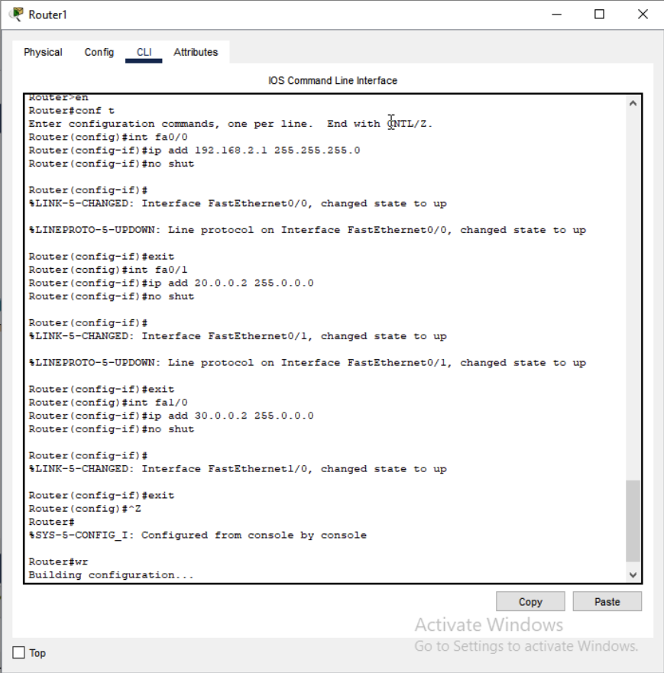Router1
     3. 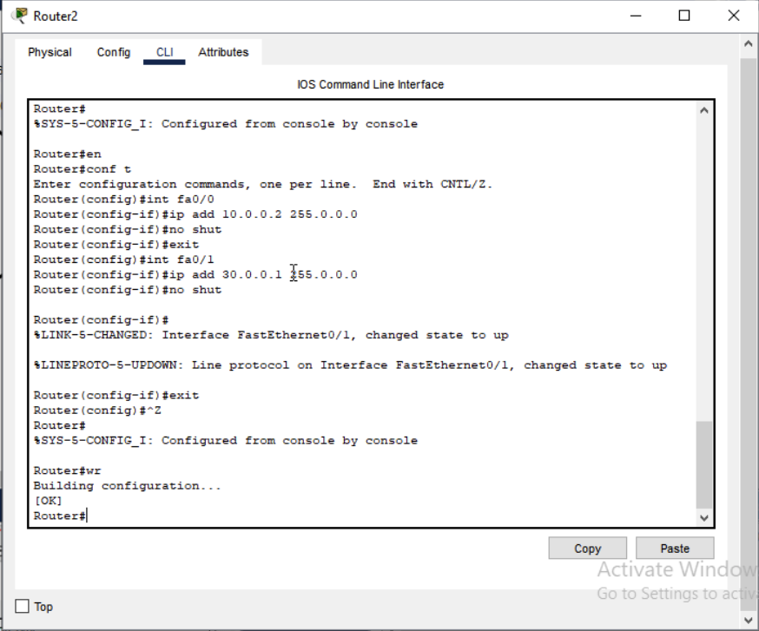Router2

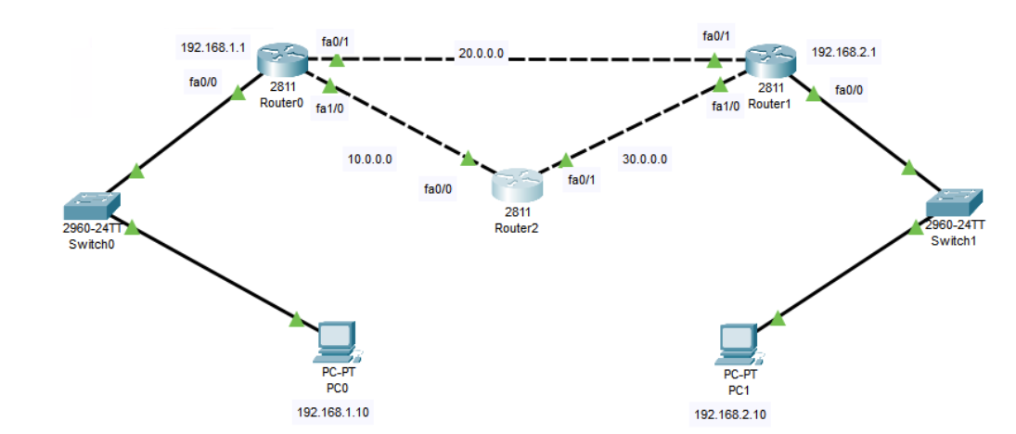**After Router Configuration**

* 1. OSPF Configuration on
     1. 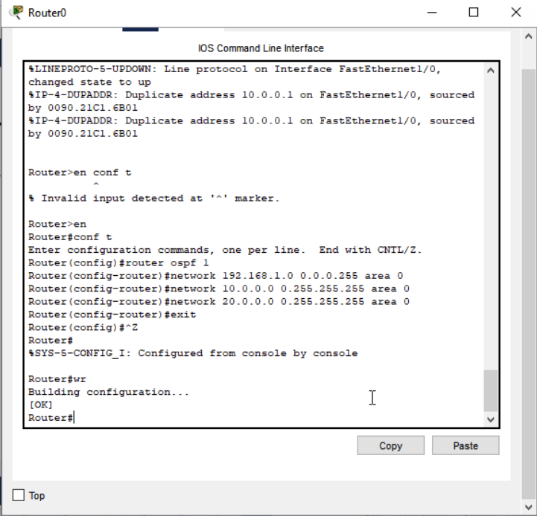Router0
     2. 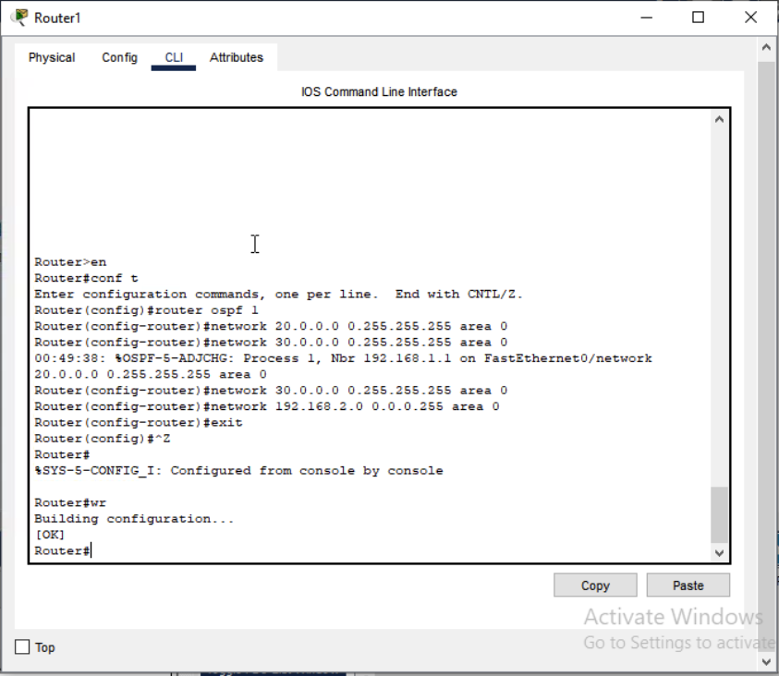Router1
     3. 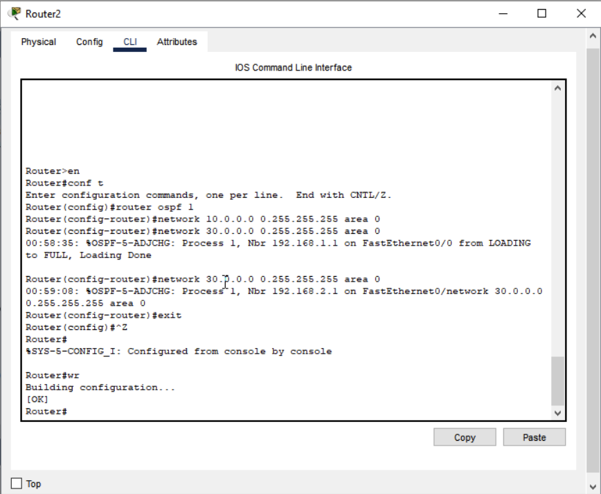Router2
  2. 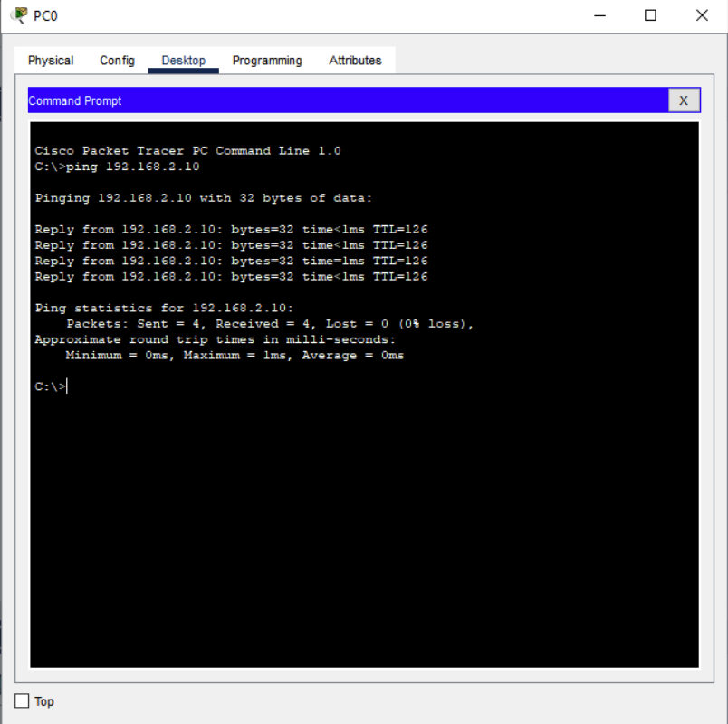Ping PC1(IP: 192.168.2.10) from PC0 to verify

**Project Task 1:**

* Objective:

Create a domain controller using domain name as <your-name>.training and create a shared NFS folder (c:\sharables) on domain controller machine with read-only permissions and access this folder on the member machine.

* 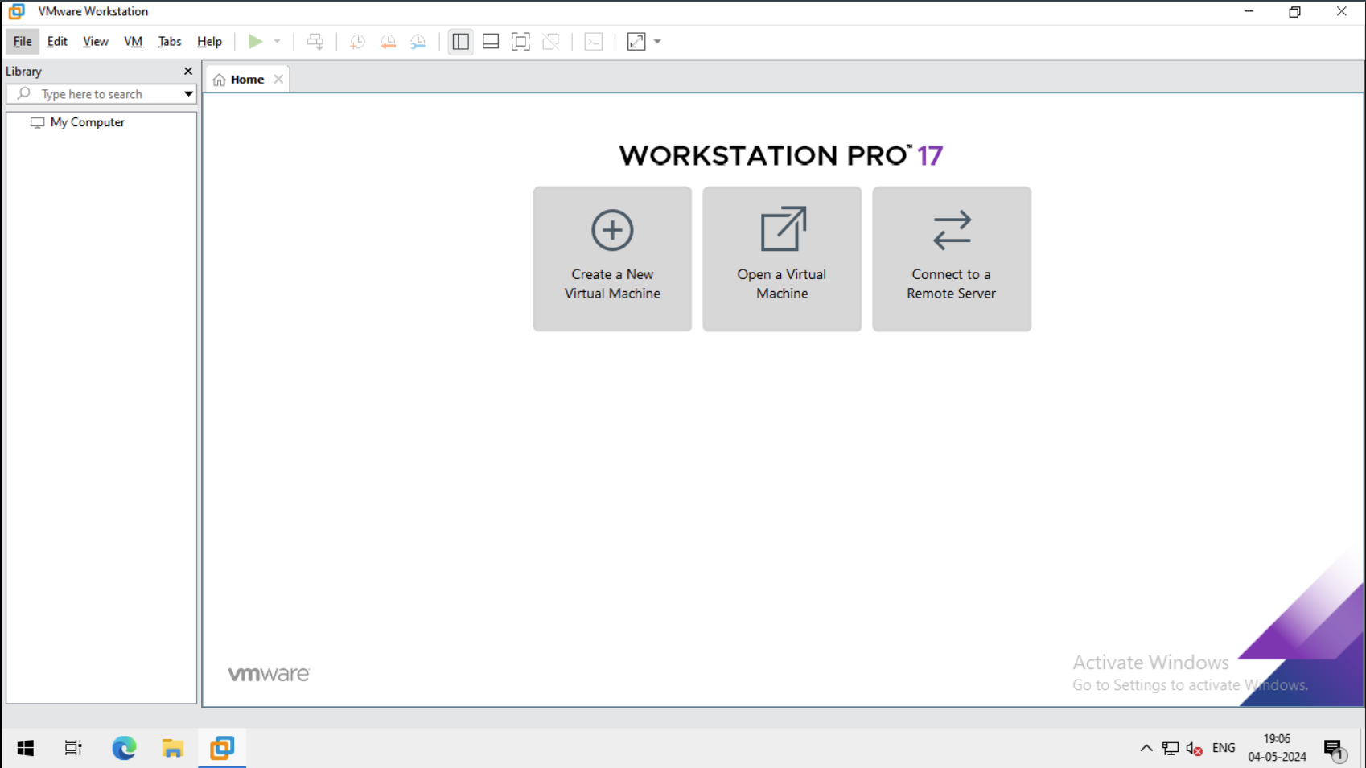Installation of Windows Server 2016 as “**DC_Server”**

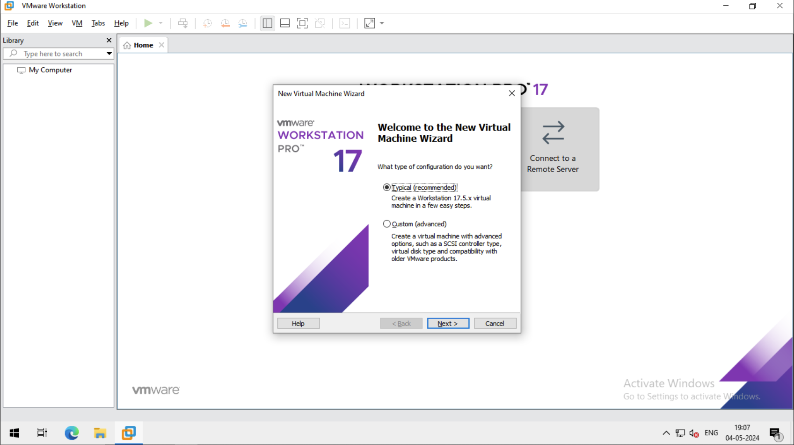

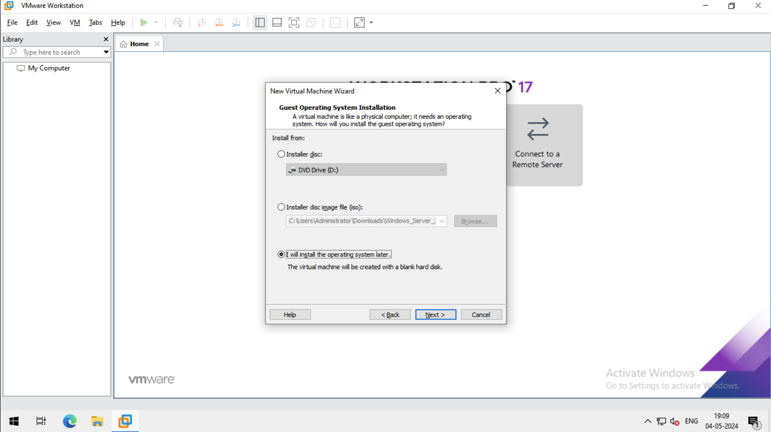

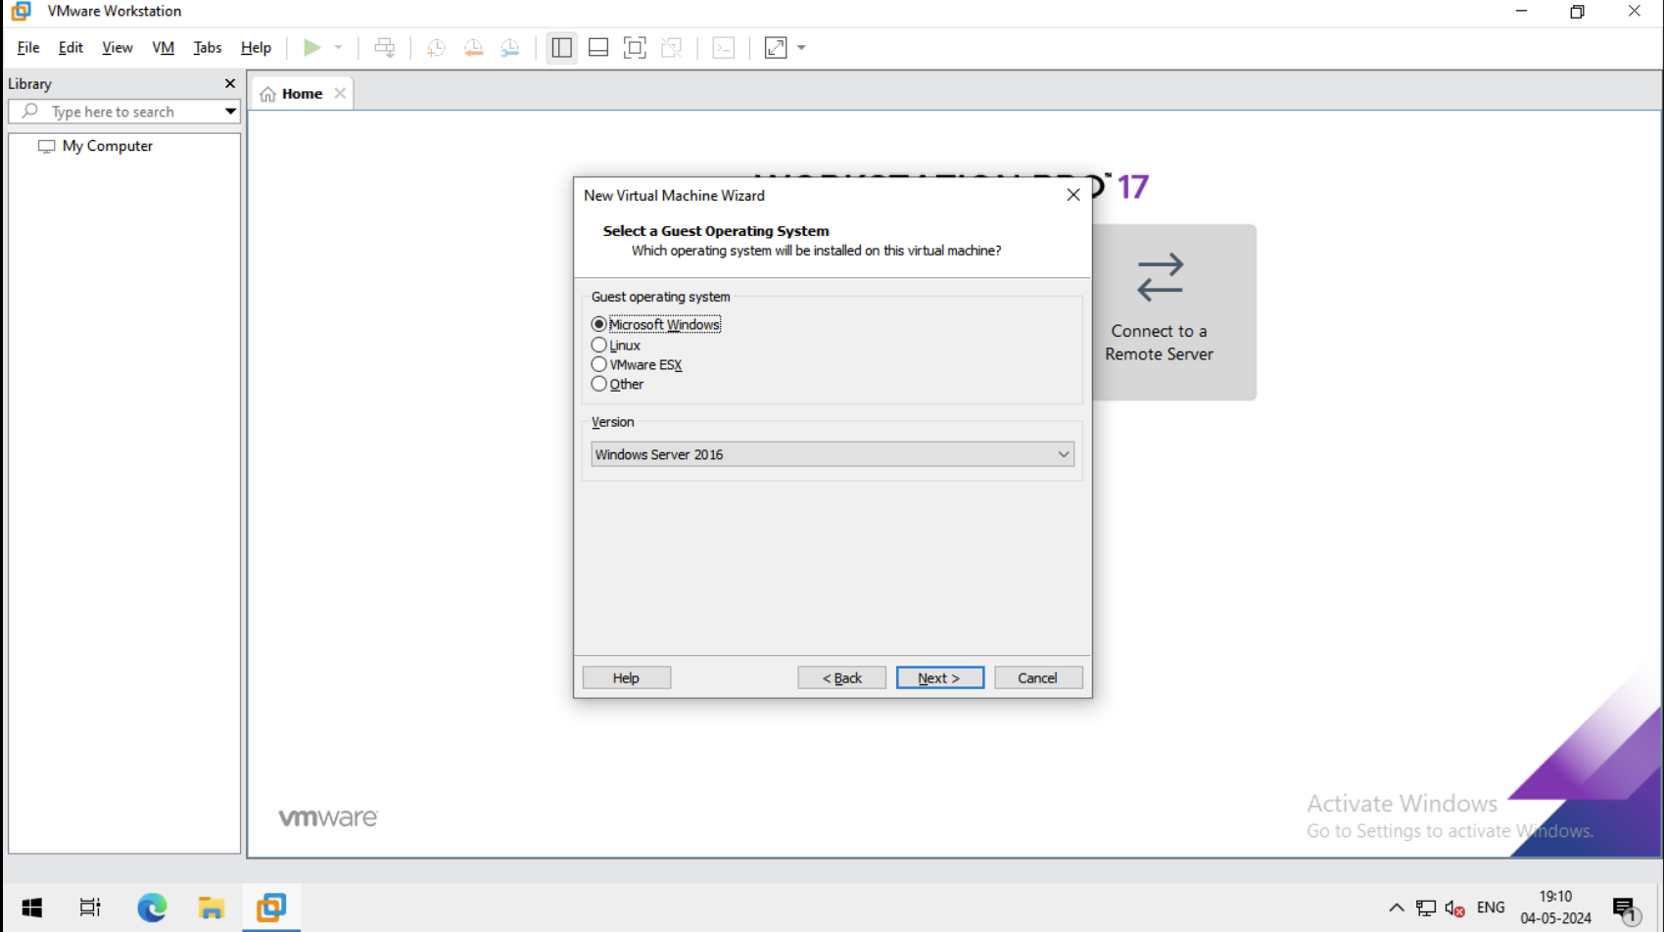

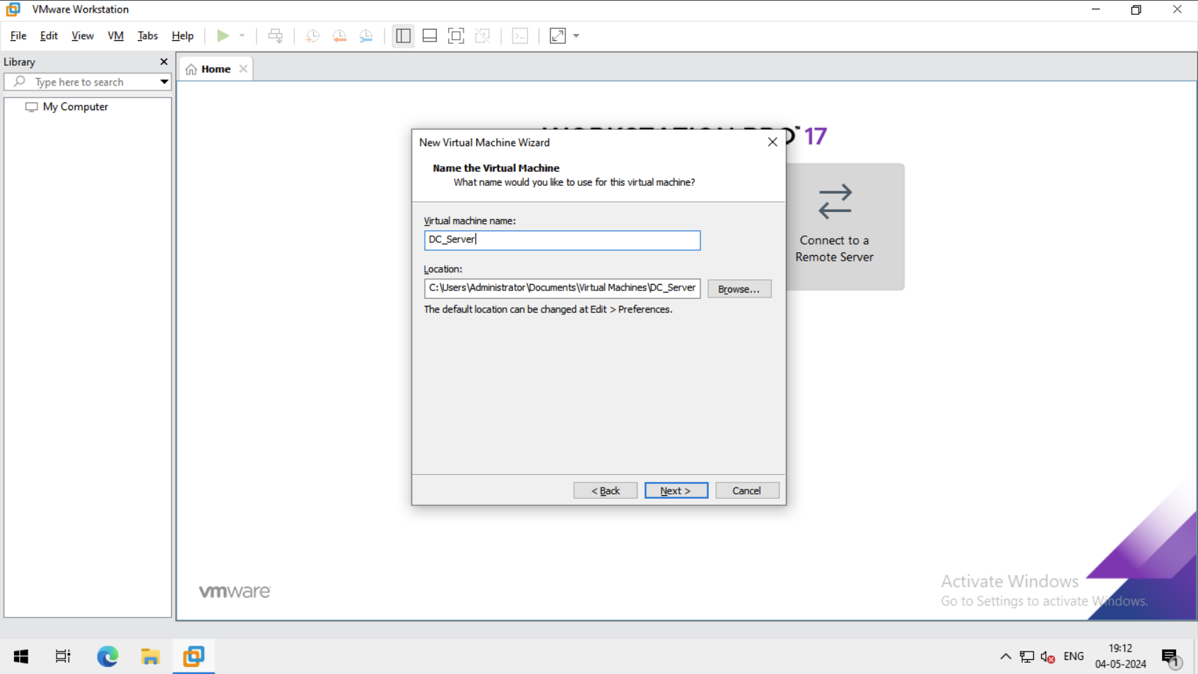

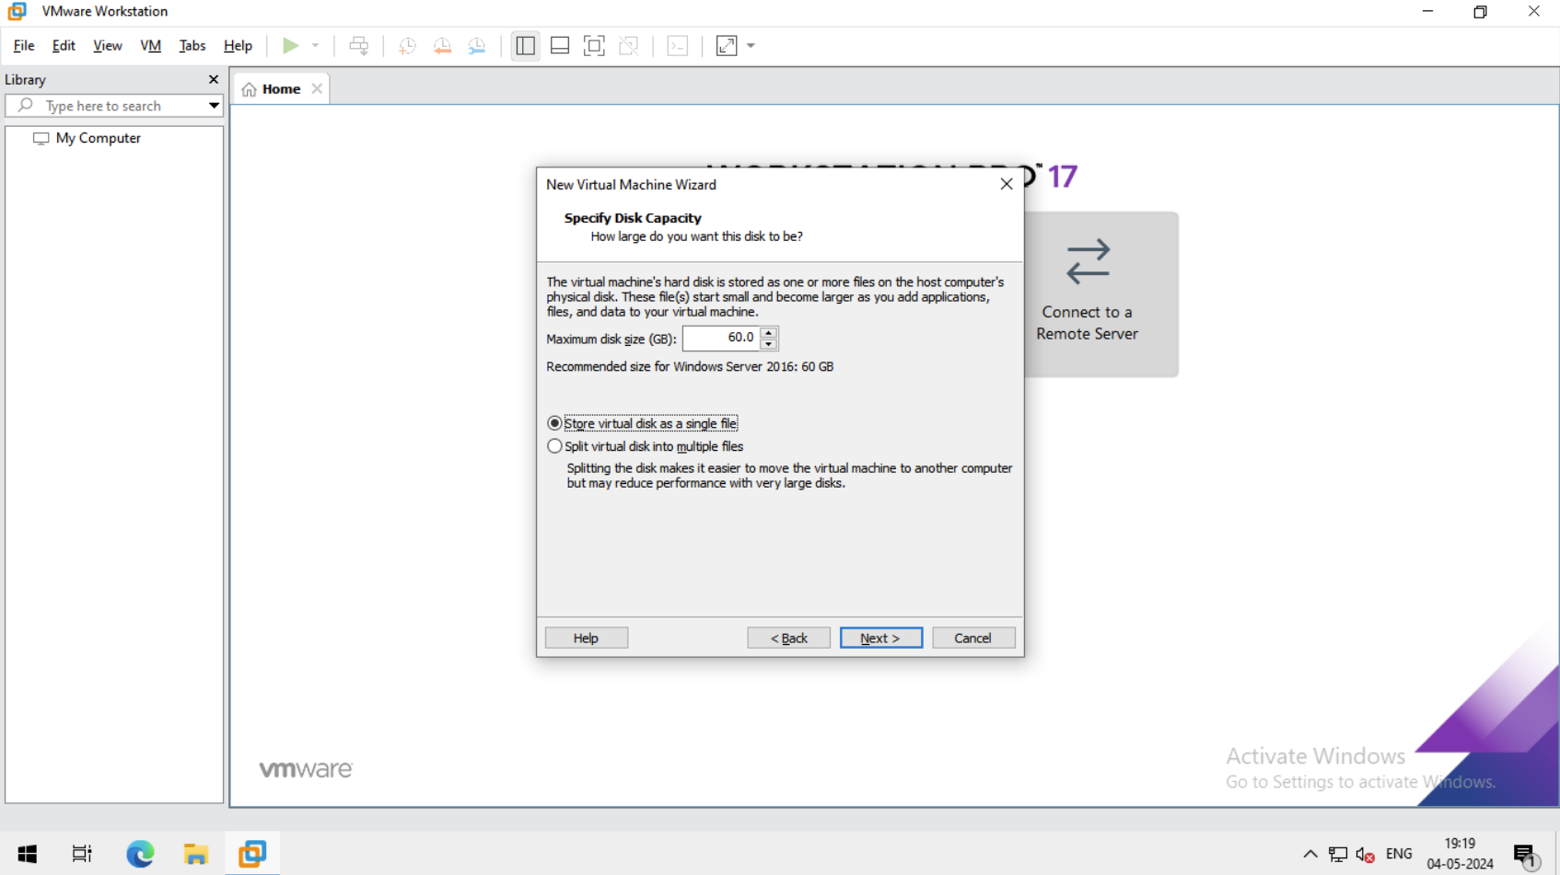

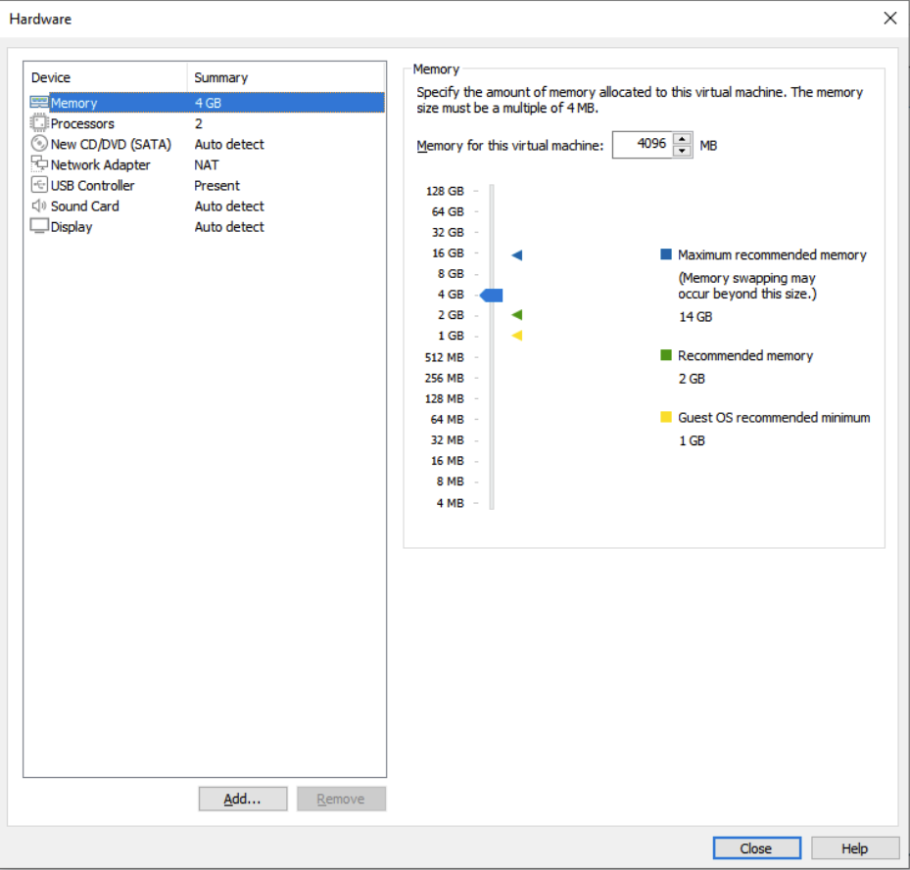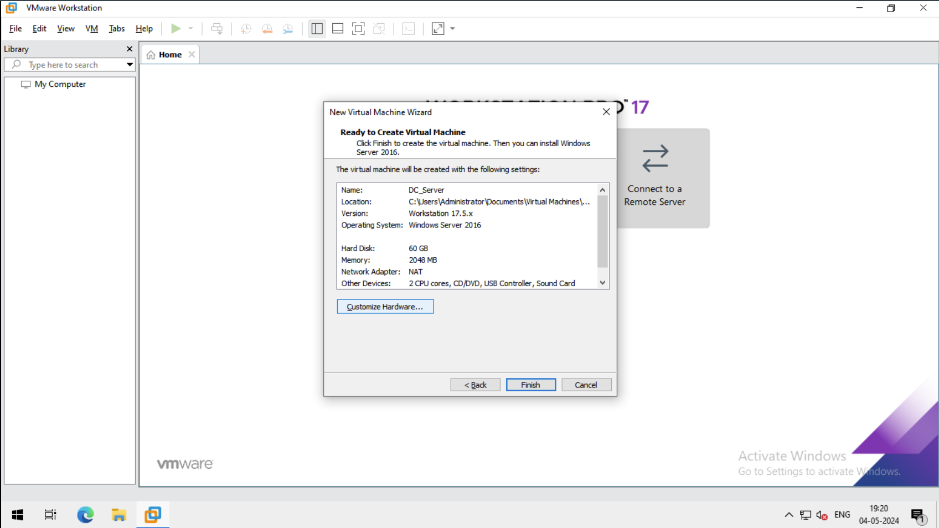dfasdf

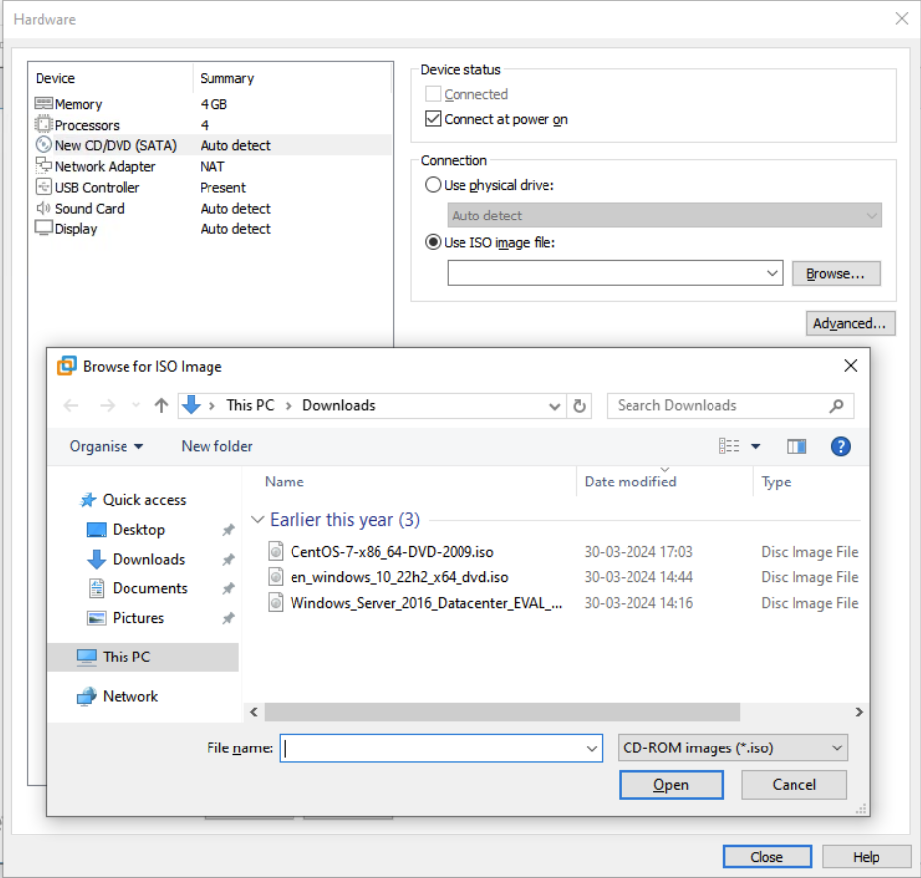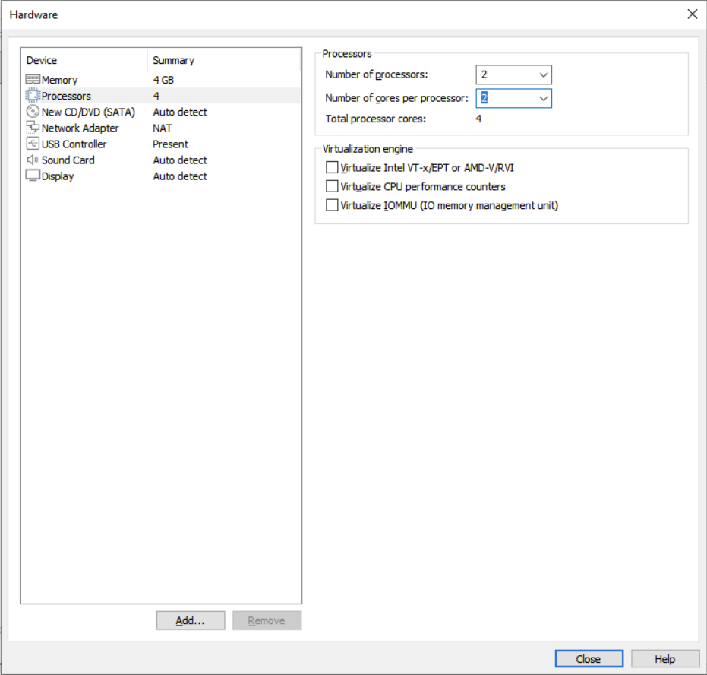fgsdf

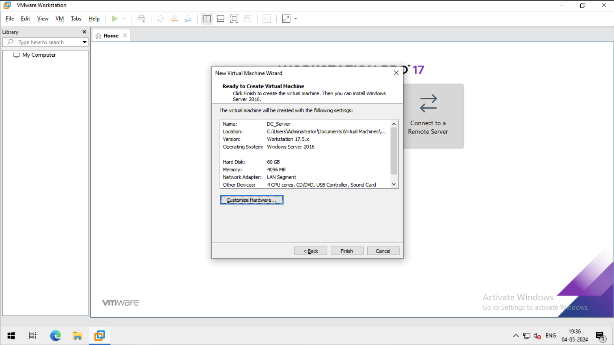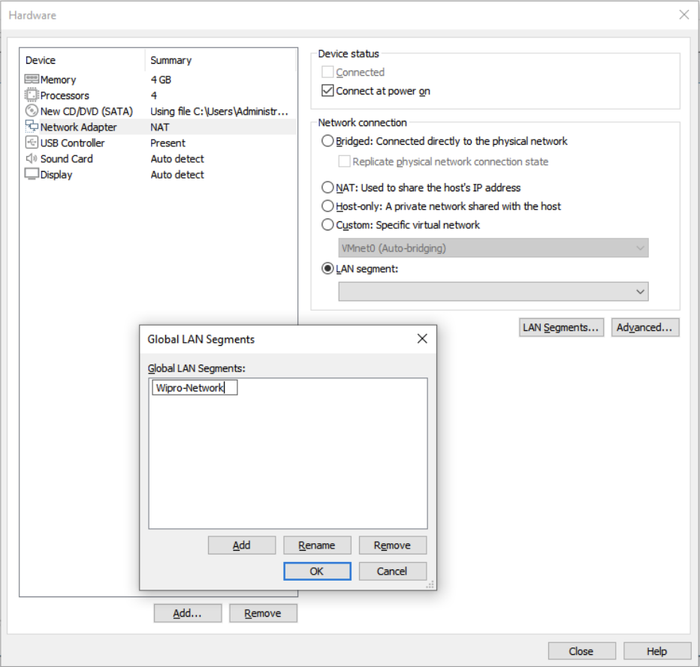dsfasdf

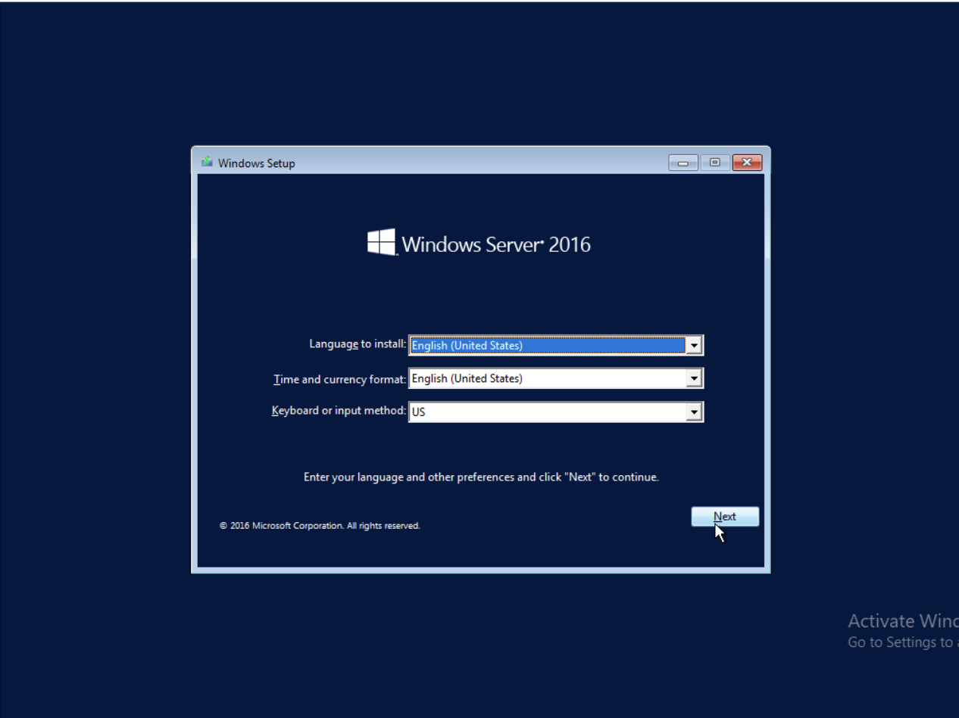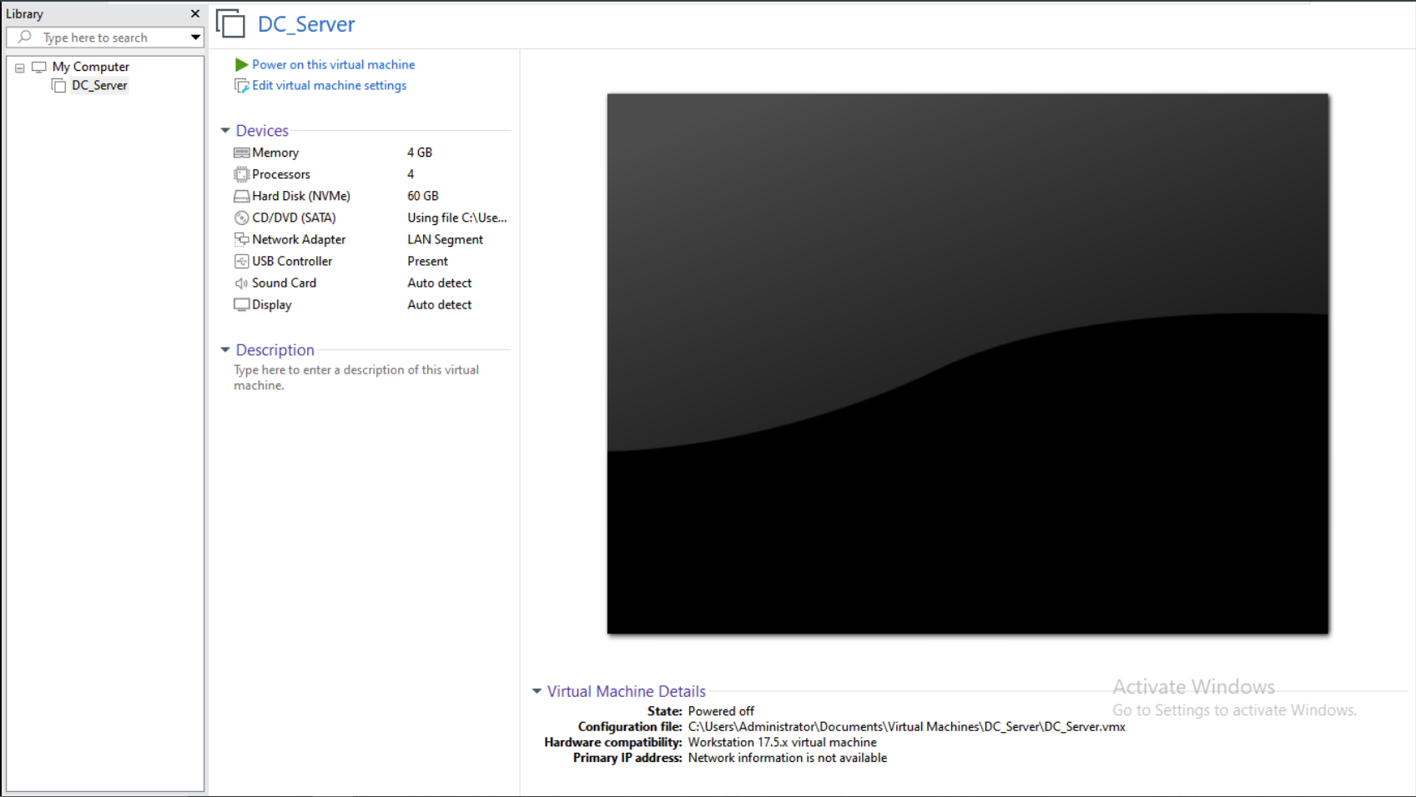sdfs

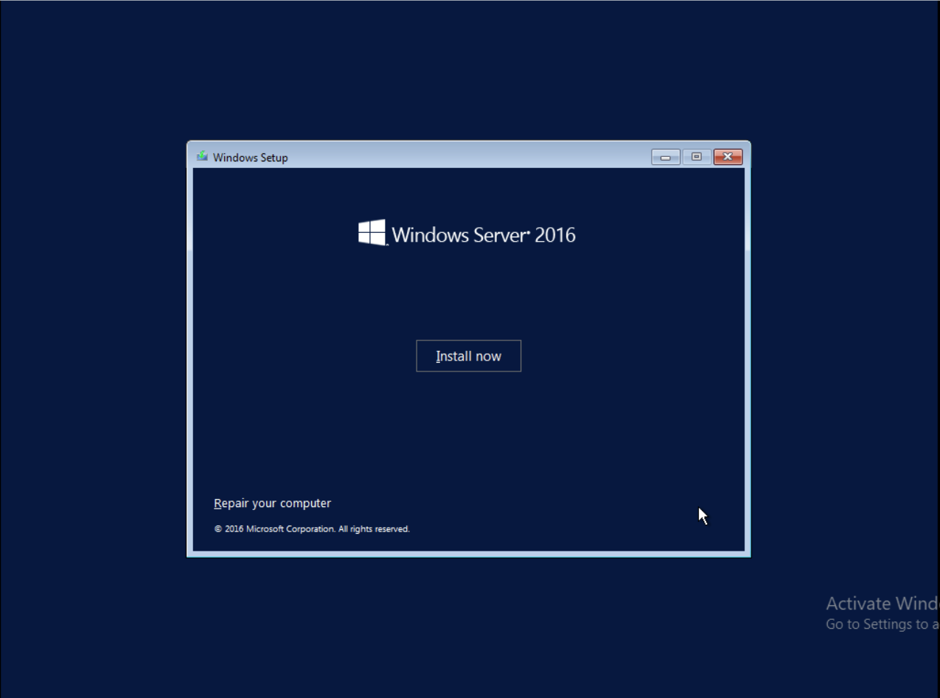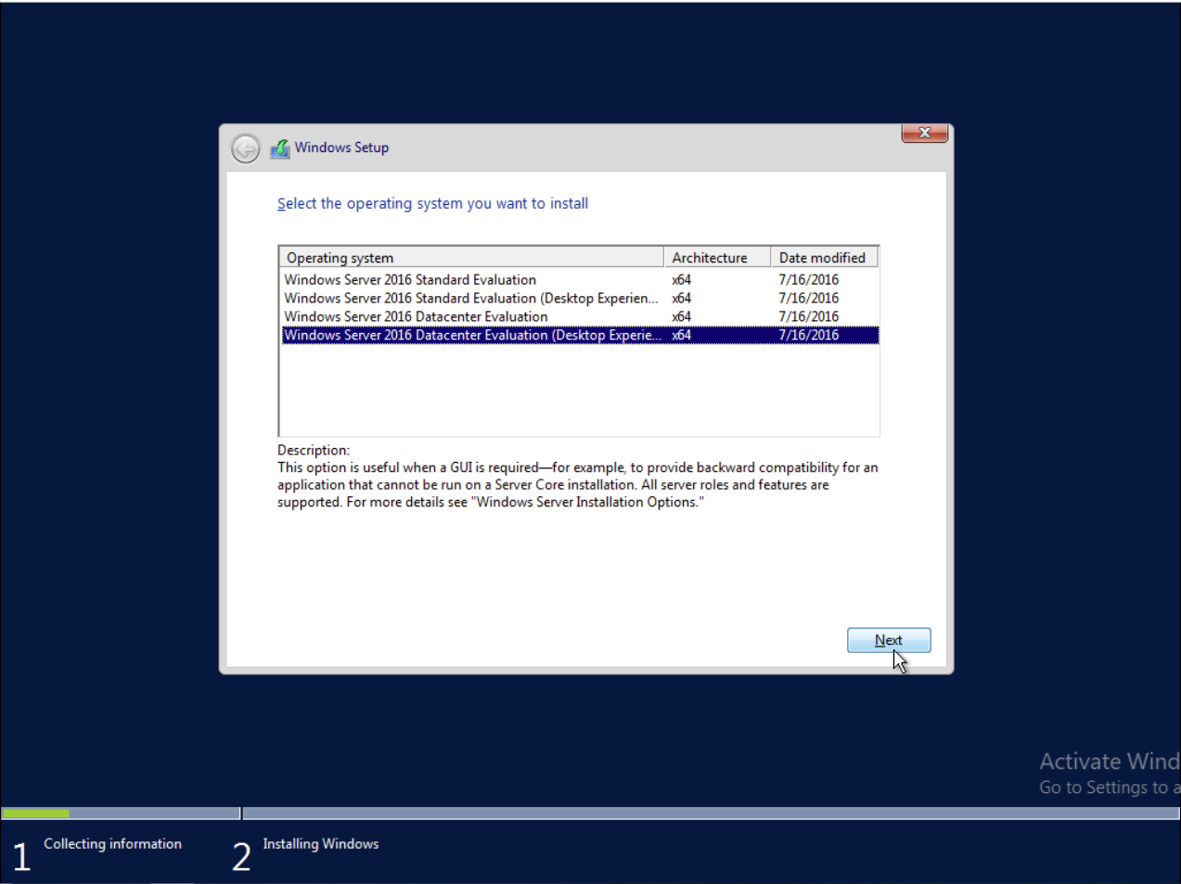dsfs

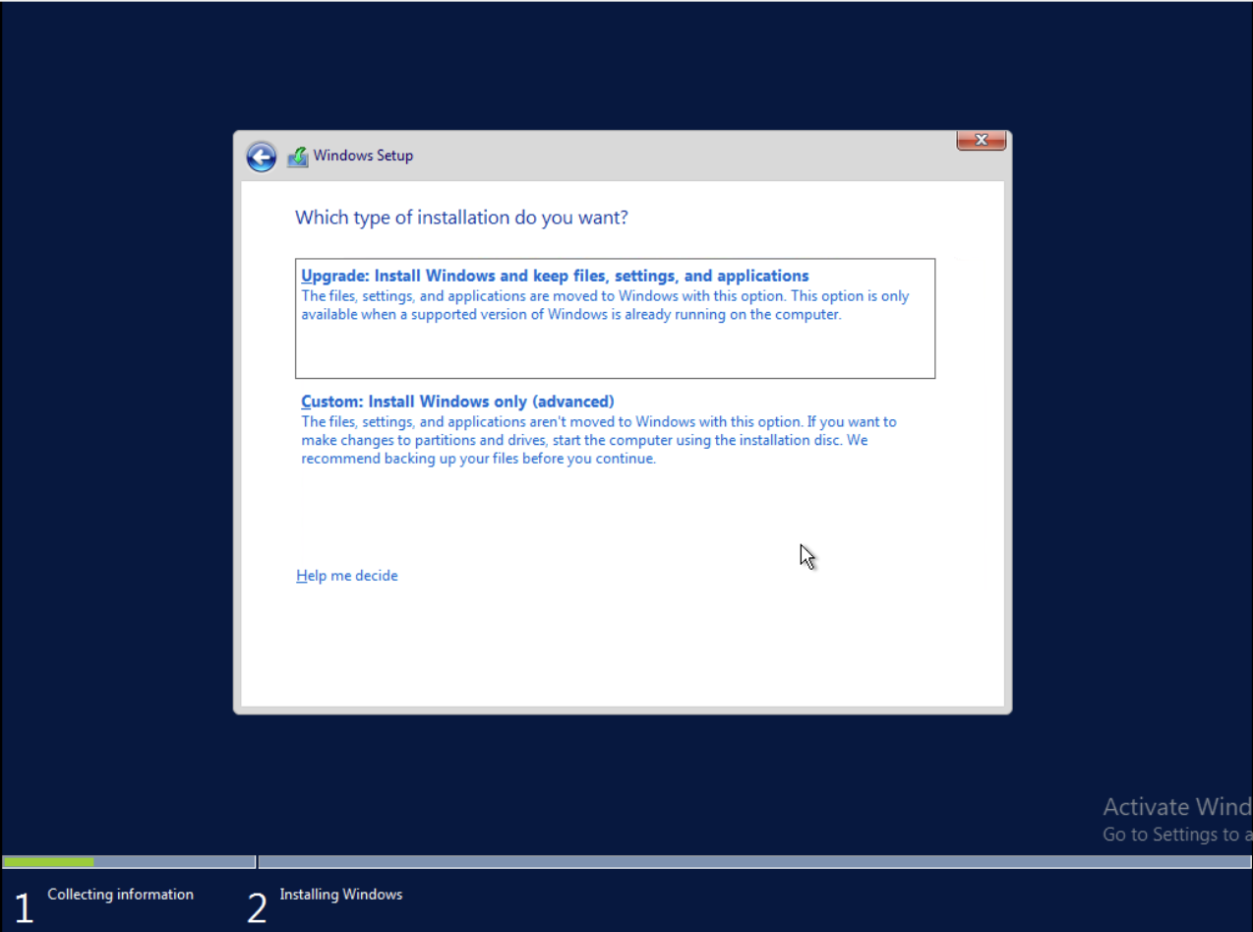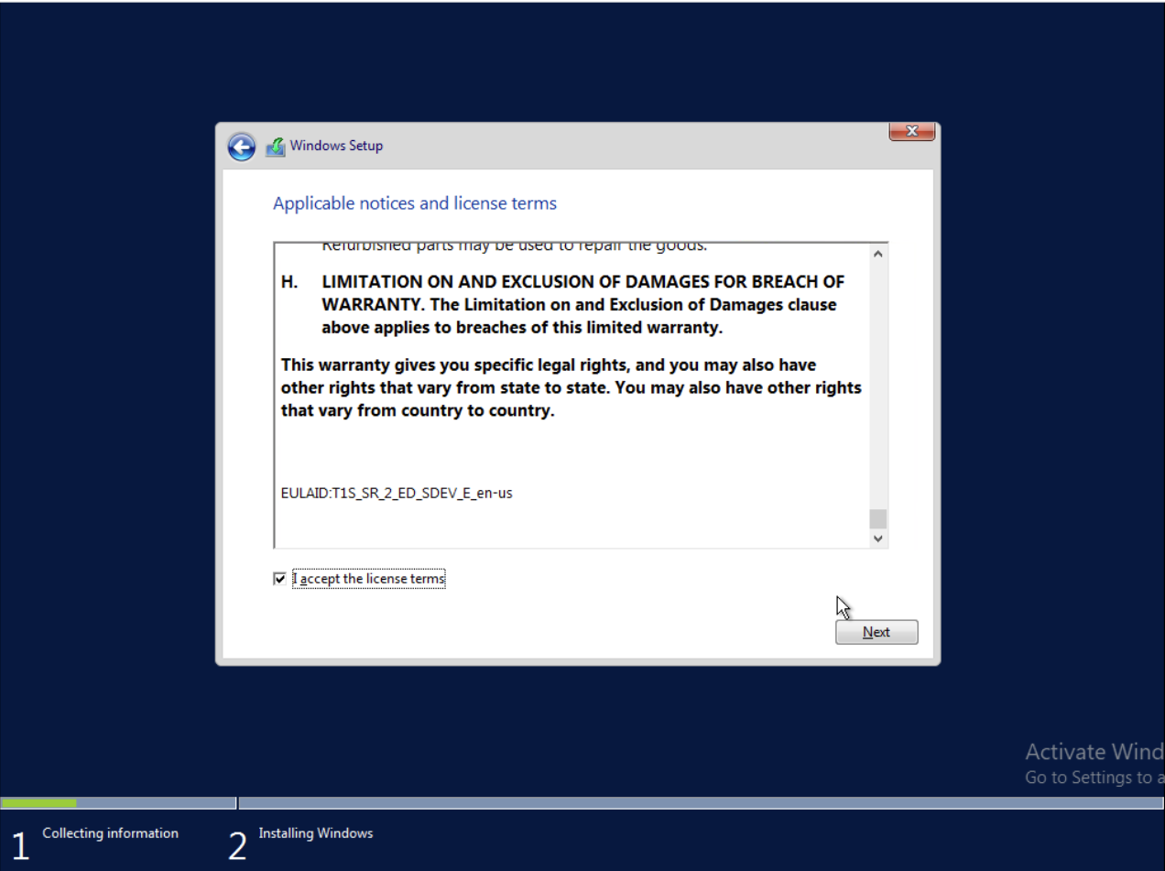d

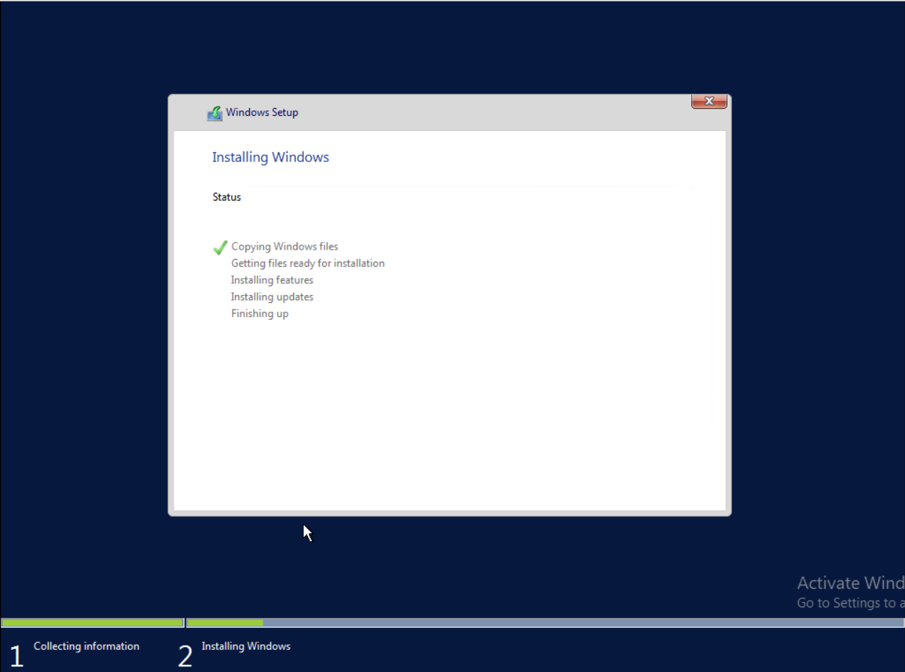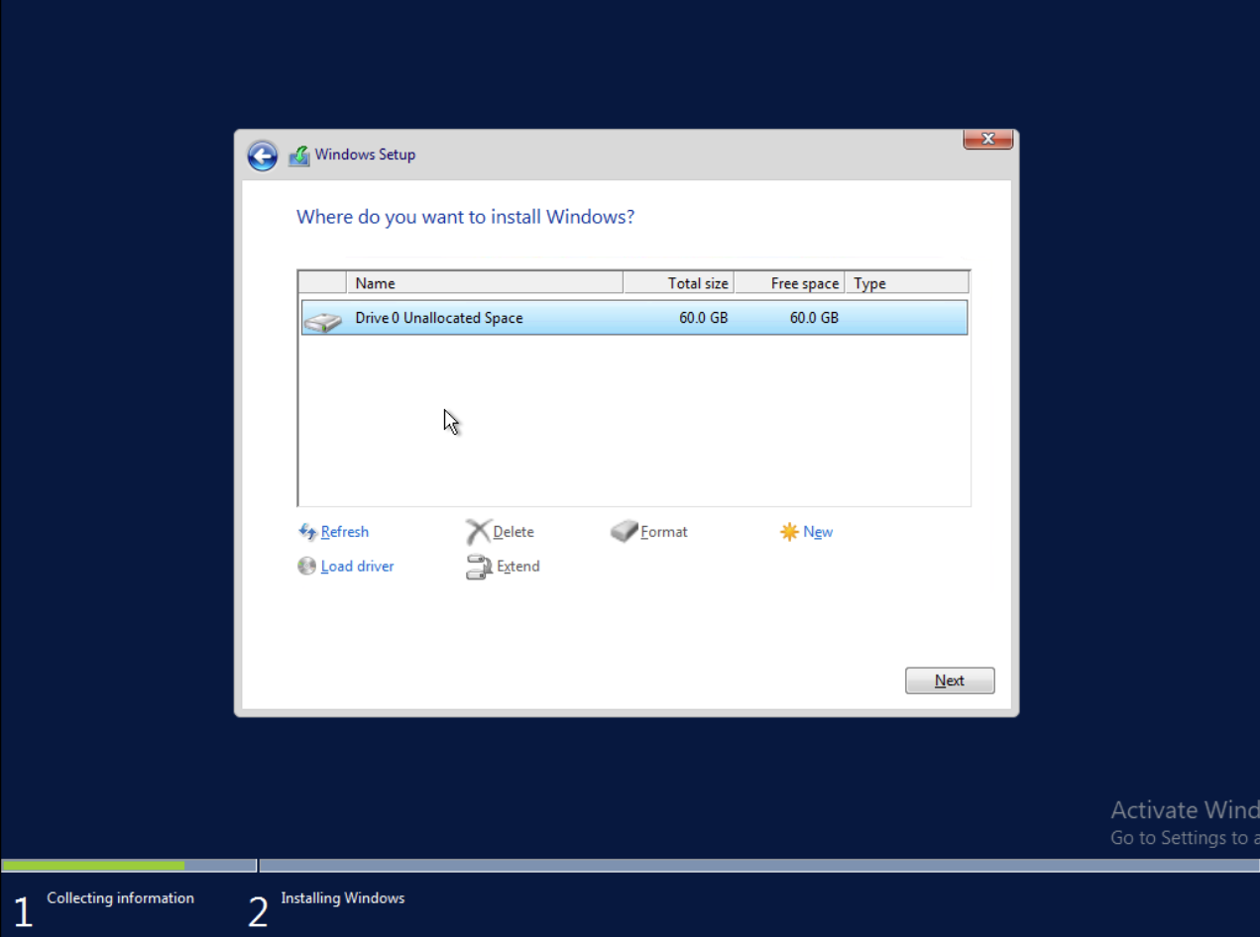d